Department of Electrical Engineering

San Jose State University

**EE 198B Senior Project**

**Energy Management System (EMS)**

**for Storage Cells in Electric Vehicles (EVs)**

Andrew Tran (012394096)

Hiromi Saito (014065129)

Jonathan Austin (012148162)

December 6, 2021

Project advisor: Dr. Mohamed Badawy

# Executive Summary

Electric Vehicle (EV) sales have been growing at a rapid pace for the past decade. The increase in electric vehicle drivers benefits the environment as it reduces carbon dioxide emissions. The Energy Management System (EMS) for Storage Cells in EVs project is meant to combine two common systems in EVs, the inverter and Battery Management System (BMS), in a more cost effective, efficient, and modular way to make EVs more appealing to customers. The modular approach to combining the inverter and BMS includes creating a multi-layer device where each layer can control its own portion of the output voltage signal. This is done to power a 3 phase DC motor. Each submodule within the layers includes a H-bridge switch that’s capable of outputting 0V, +Vout, and -Vout. The PCBs that contain the multilevel inverters are currently directly controlled by a Digital Signal Processing (DSP) controller.

# Table of Contents

**Executive Summary** **1**

**Table of Contents** **2**

**I. Introduction** **3**

**II. Project Overview** **3**

A. Current Hardware System 3

Figure 1. Current Hardware System 4

**III. Power Module Design** **4**

A. Current Sense Schematic 4

Figure 2. LDO used to power Current Sense Module 6

Figure 3. Current Sense Module 6

B. Printed Circuit Board (PCB) 8

Figure 4. 4 Layers of the Current Sense PCB 9

Figure 5. Closer Look at the Bottom Layer 10

Figure 6. Bay Area Circuits Generated View of the Top and Bottom Layer of Current Sense PCB 11

C. Simulation Results 13

Figure 7. Output Waveforms 13

**IV. Embedded Systems (ES)** **13**

A. DSP PWM Signals 13

Figure 8. MP-MMC SM modes a) battery, b) UC, and c) battery and UC in series 14

Table 1. Sub-module Converters Switching States 14

Figure 9. Schematic to locate the PWM modules used for testing 15

Figure 10. DSP board with test board, probed by the ADALM2000’s Logic Analyzer 15

B. Adapted Sorting Algorithm 15

Figure 11. Creating and sorting the main matrix based on SOC 16

Figure 12. Evaluating the PWM modules with highest SOC and updating main matrix 17

C. PWM Output Results 17

Figure 13. PWM waveforms with level 4 on DSP 18

Figure 14. Waveforms before SOC Algorithm 18

Figure 15. Waveforms after SOC Algorithm 19

Figure 16. Waveforms before SOC Algorithm (zoomed in) 19

Figure 17. Waveforms after SOC Algorithm (zoomed in) 20

D. Kalman Filter Research 20

Figure 18. MPC structure applied to MP-MMCs for an EV drivetrain 20

Figure 19. MPC structure simulation in MATLAB 21

Figure 21. Equivalent circuit model used for the Li-ion battery cells 22

Figure 22. Block diagram of the SOC estimation process 22

Figure 23. Kalman Filter simulation in MATLAB 22

**V. Future Work and Considerations** **23**

**VI. Conclusion** **24**

**References** **25**

# I. Introduction

The energy management system of storage cells project tackles environmental issues and the conventional practices of the EV industry. Firstly from an environmental perspective, the EMS project contributes to decreasing carbon emissions by making EV’s more enticing to consumers. The EMS project does so by lowering the cost of the EV for the long term by decreasing the costs of maintenance of their cars. Secondly, it is predicted that the EV market will have a total share of the car industry of about 35% in 2035 [2]. Current standards for conventional design for EVs is to separate the inverter and battery management system. This results in more expensive manufacturing for EVs as well as higher cost for maintenance. So as EV sales increase, so will these same manufacturing and maintenance problems. A solution to this issue is this project where it will combine the inverter and battery management system to be one modular system. This will result in a decrease for manufacturing costs as well as lowering the difficulty and cost for maintenance.

# II. Project Overview

## A. Current Hardware System

The current hardware for the Modular Multilevel Converter (MMC) consists of a current and voltage sensor, an inverter board, gate drivers, an H-bridge circuit, and a digital signal processing (DSP) controller (Figure 1). The purpose of the sensors is to track the voltage and current levels and send them to the FPGA. If any issues were present in the MMC, the voltage or current levels would change, and using the FPGA that specific board would be shut off. The gate drivers are used to control the MOSFET’s switching times of when it turns on and off. The gate drivers act as a power amplifier, meaning that they can dissipate heat from the MOSFET and mitigate the losses in switching frequencies. The H-bridge circuit is responsible for generating the PWM signal that would be sent to the motor. The DSP controller holds the PWM modules that would be used to turn on or off the switches of the H-bridge.

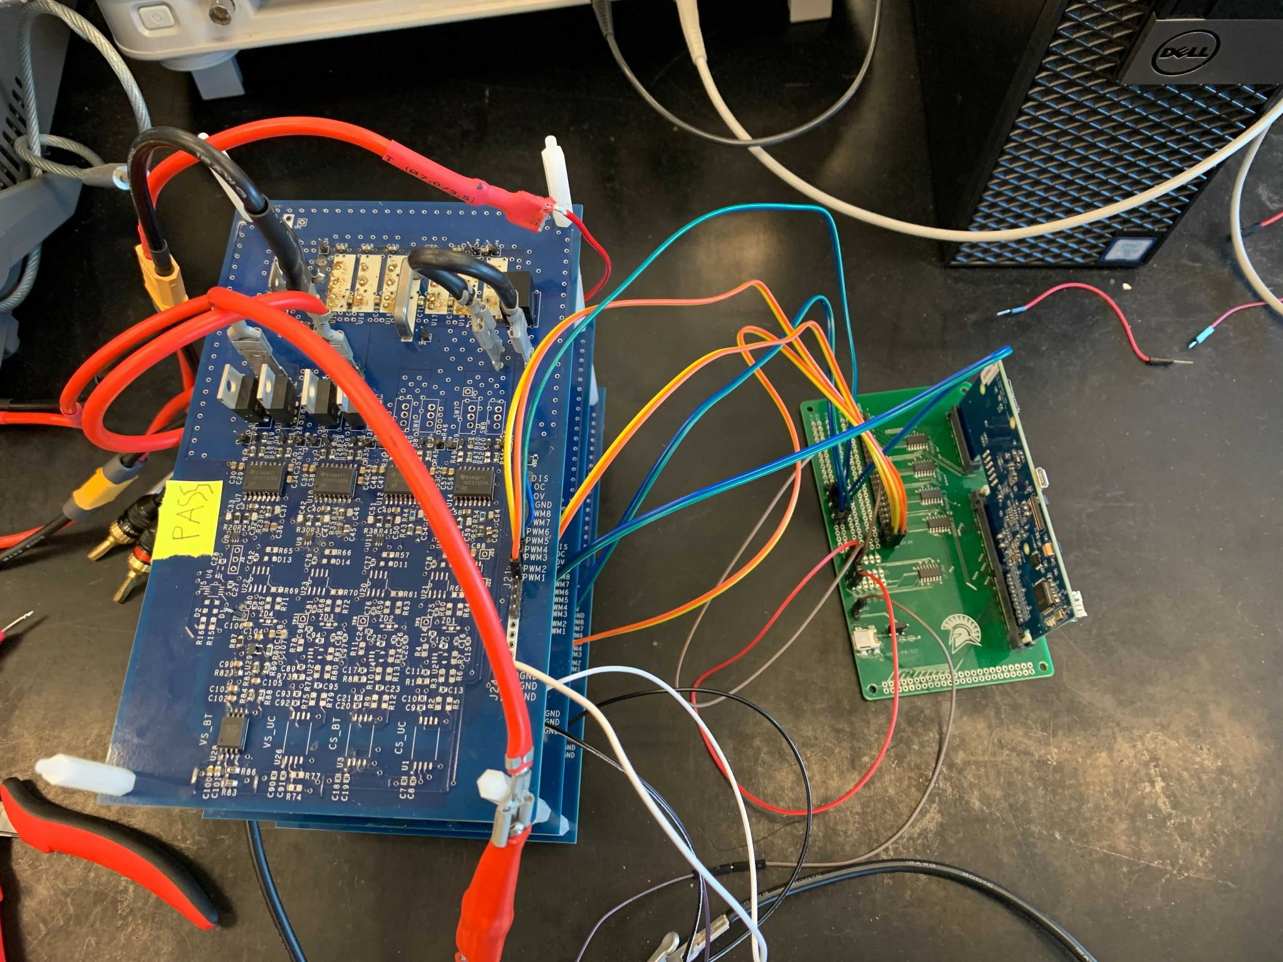

### Figure 1. Current Hardware System

# III. Power Module Design

## A. Current Sense Schematic

Below in figures 2 and 3, is the current sense module that will be used for testing, sensing current, and outputting a signal to the FPGA. The current sense module is powered by the LLC circuit. The LLC circuit will be sending 6V to the low-dropout regulator (LDO) which takes the input 6V and regulates it to 5V for the current sense module. The reason we chose to power the circuit using the LLC circuit is because of the noisy reference to ground if we had powered the module using the system’s batteries. The previous iteration of the current sense module was powered by the system batteries. Because we had multiple levels of battery cells, there was not a distinct reference to ground unless it was connected to only the first level. For example, if we had two 12V batteries connected in series, the measured voltage would be 24V across both of the batteries. If we took the voltage measurement of the second battery, we would see 12V, but that 12V that is measured is the voltage difference between 24V and 12V, which is different from measuring 12V to 0V or ground. By adding the LDO to the current sense module, we can eliminate the noisy references to ground by having a source with a common ground. Due to chip shortage, we were not able to get the LDO we wanted to use for the current sense module. As an alternate option, we added a test hook, which would allow us to connect a DC power supply in place of the missing component.

### Figure 2. LDO used to power Current Sense Module

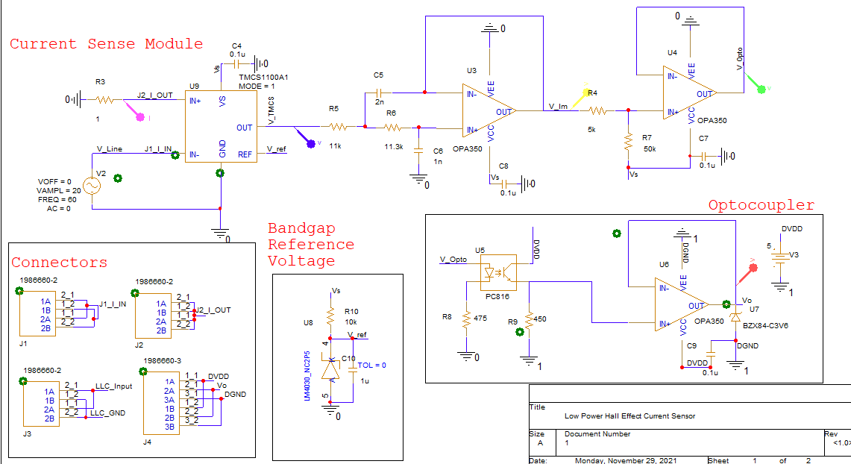

### Figure 3. Current Sense Module

In addition, we swapped out the TMCS1100A2 for the A1 version because the A2 version was out of stock and just like the A2 version, the TMCS1100A1, is a galvanically isolated Hall effect current sensor that is capable of DC or AC current measurement with high accuracy, excellent linearity, and temperature stability [4]. The benefit of using the A1 instead of the A2 is higher sensitivity. Because of the higher sensitivity, some resistor and potentiometer values needed to be readjusted to maintain the sensing sensitivity of the circuit. In the signal conditioning portion of the circuit, we left the first stage of the Butterworth filter because it was already set to filter out high frequencies because our circuit will be working in the frequency range of 60Hz to 12kHz. After the first stage, the second OPA350 is added to act as a buffer to help with the loading to maintain the signal as it is sent into the optocoupler. When the TMCS1100A1 senses the 40A peak-to-peak, it outputs a signal from 0.1V to 5V with 5V representing +20A and 0.1V representing -20A. For the TMCS1100A1 to assign the current values to voltage values, we used an LM4030 shunt voltage reference IC to provide a precise reference voltage [5]. If we do not provide a precise voltage to the reference pin of the TMCS1100A1, the output signal would carry noise-causing disruptions to the analog signal. The two potentiometers that are connected to the optocoupler affect the gain of the signal from the signal conditioning circuit. The potentiometers of the optocoupler will shift the gain of the DC voltage from 0.1V to 5V and compress it to 0.3V to 3.3V. The reason we chose potentiometers instead of discrete resistor values is that depending on what type of optocoupler we use, the current transfer ratio will be different and the values of the resistors will change accordingly. The voltage is compressed so we can pass it to the ADC of the FPGA, which can handle voltages ranging from 0.3V to 3.3V. In addition, to another buffer after the optocoupler output, we added a Zener diode to clamp the voltage levels to 3.3V in case any transient spikes occur in the circuit. As previously mentioned, due to IC shortages, we included test hooks in various parts of the circuit as an alternative method of providing voltage to power the ICs.

## B. Printed Circuit Board (PCB)

One of the major design tasks that will be completed in the summer of 2021 is creating a PCB for the current sense schematic. Two PCB design rules that were followed are design constraints from the PCB manufacturer and for incoming high current. When designing a PCB, it is important to pay attention to the capabilities of the chosen PCB manufacturer. Usually the PCB manufacturer will provide a constraint file that auto generates constraints into your PCB software. The project advisor had chosen Bay Area circuits as this project’s PCB manufacturer. Unfortunately, Bay Area circuits does not provide a constraint file for this project’s chosen PCB software, OrCAD PCB Editor. A necessary step that had to be taken in order to produce a PCB was to learn how to transfer the constraints from Bay Area Circuits capabilities page into OrCAD manually. Another design constraint that had to be followed is designing for high current. One of the main points for designing a PCB that will be used for high currents is ensuring that the current contacts are large enough to handle the high amounts of current. This includes creating a large polygon pour where the software PCB tool kit version 8.05 by Saturn PCB was used in this project’s case to determine the dimensions of the polygon pours. The size of the polygon pours with respect to the components can be seen in the figure below. For extra safety measures, the outer copper layers of the current sense PCB were designed to be 2 oz in order to help the connectors hold up against the high incoming current. Also, via arrays were added around the board and a ground plane was added to the bottom layer to help increase the impedance throughout the stackup.

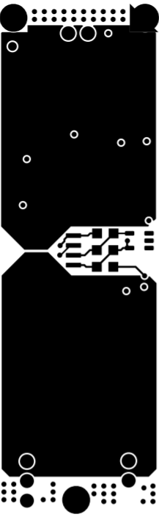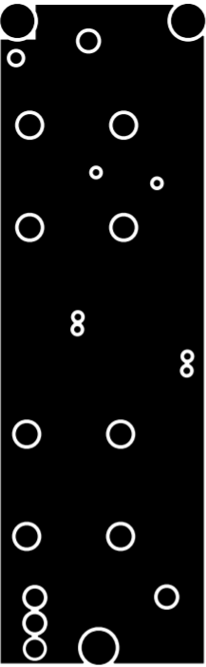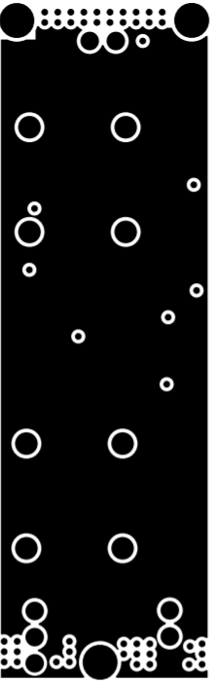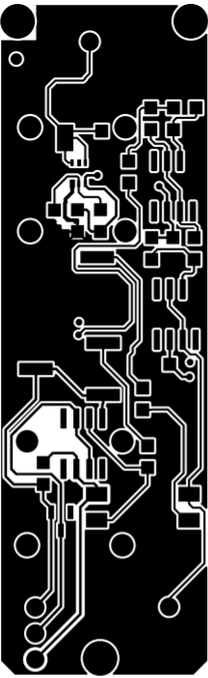

### Figure 4. 4 Layers of the Current Sense PCB

The current sense PCB is made up of a total of four layers. The top layer includes the polygon pours as well as a few of the components in the current sense schematic. The second layer down is the power layer. The power layer is receiving it’s a voltage from the LDO which is located on the bottom layer. The third layer down is the ground plane used for the analog side and to reduce interference from the top layer and bottom layer . Lastly, the bottom layer is where most of the components from the current sense schematic are located.

Generally, industry standard PCB design rules were followed during the construction of the current sense PCB. Another example of a general, industry standard PCB design rule is placing components that are on the incoming side for ICs close to the input pins while keeping components on the output side farther away. A larger image of the bottom layer can be found in the figure below:

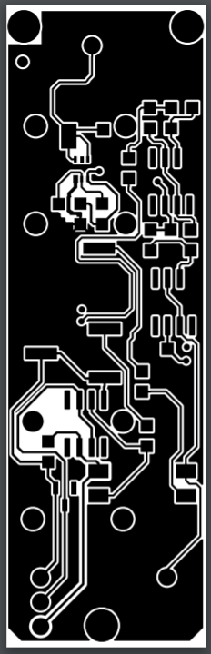

### Figure 5. Closer Look at the Bottom Layer

Another constraint to keep in mind for PCB designing is available components on the market as well as the project’s budget. To stay within the given budget, most of the connectors selected are through hole type. This posed some design obstacles as the rest of the components had to be placed in a way in order to avoid the through-hole pins. Pragmatically, there’s going to be sacrifices made for placing components with respect to industry standards due to component selection but this is a reality PCB design engineers must learn how to work around.

Next step after once the PCB has been fully assembled and has passed the DRC check is to generate the gerber file. The gerber file is the information that is required by the PCB manufacturer in order for them to perform their own check on the PCB design and to provide verification on the finalized version of the board. Once the current sense PCB had been finalized on the PMD team side, the gerber file was generated and submitted to Bay Area Circuits. The figures below are previews of the top and bottom layer of the current sense PCB generated by the Bay Area Circuit:

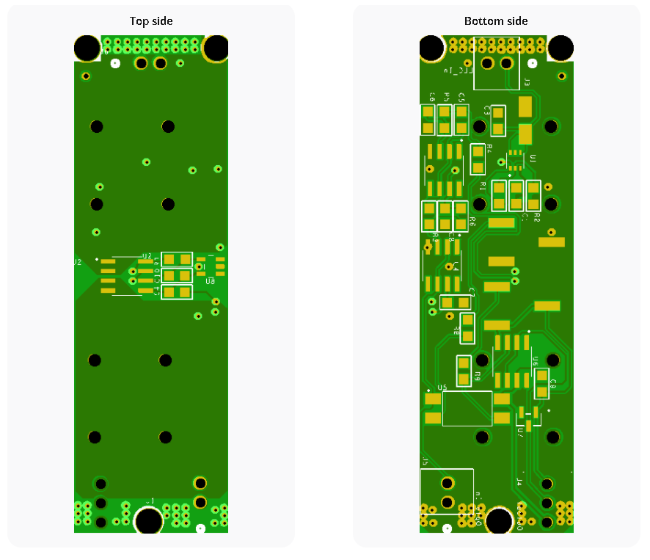

### Figure 6. Bay Area Circuits Generated View of the Top and Bottom Layer of Current Sense PCB

The PMD team learned about how to transfer schematic files from OrCad Capture into OrCad PCB Editor. Polygon pour calculators such as the PCB toolkit V8.05 by Saturn PCB was used and it taught how to create appropriately sized contacts for specific requirements such as temperature change, copper weight, and amperage. Extra safety measures to ensure the operation integrity for the components directly connected to the high current polygon pours involved including via arrays around the board, increasing the copper weights on the outer layers to 2 oz, and adding a ground plane to the bottom layer. Essentially, the various techniques were utilized to increase the ground impedance. The PMD team also learned how to use OrCad Padstack editor in order to create custom footprints for components whose footprints are not readily available. Bay Area Circuits accepted the finalized current sense PCB design meaning the PCB is verified for manufacturing. In the end, a current sense PCB about the size of a thumb drive that can handle up to 20A was created with extra safety measures to increase the ground impedance.

## C. Simulation Results

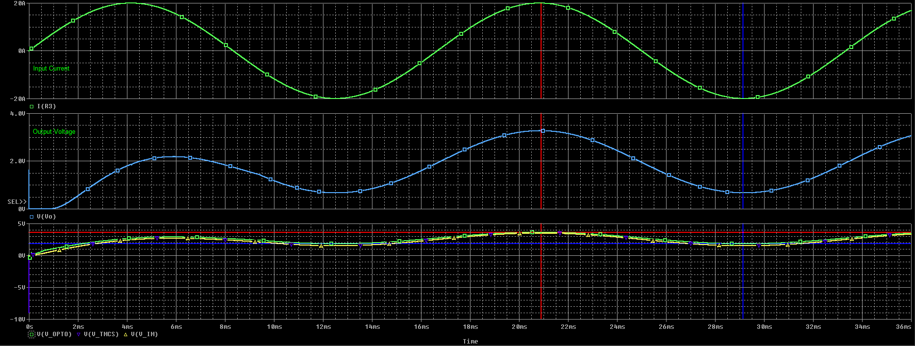

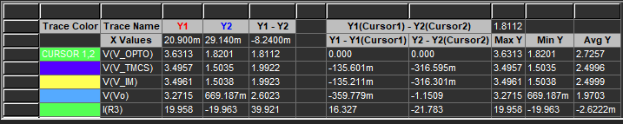

### Figure 7. Output Waveforms

# IV. Embedded Systems (ES)

## A. DSP PWM Signals

In order to provide the PWM signals for the H bridge shown in Figure 8, switches 1 - 4, a Texas Instruments C2000 DSP controller was programmed. Given our current hardware setup only includes batteries within the submodules, switches 1 - 4 are the only switches needed, meaning that switches 5 - 7 can be removed. Given that configuration a) in Figure 8, is the only possible mode of operation, this means that “Battery Low Power Mode” is the only section that was focused on when designing the code (Table 1).

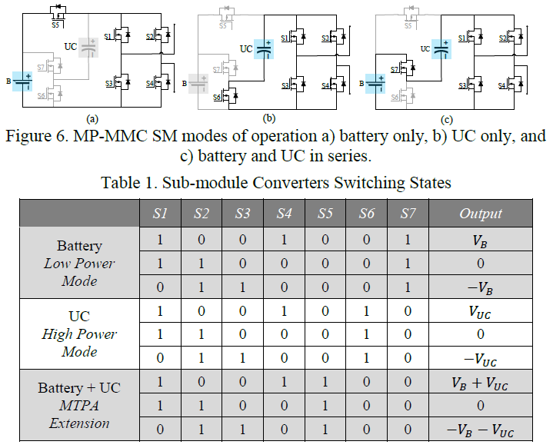

### Figure 8. MP-MMC SM modes a) battery, b) UC, and c) battery and UC in series

### Table 1. Sub-module Converters Switching States



The current code utilizes PWM modules 1 - 4 which each contain a pair of PWM channels, a low and high frequency channel, which makes for a total of 8 output channels (Figure 9). The green board that the DSP interfaces with in Figure 10 is probed for testing with Analog Devices’ ADALM2000, operating as a Logic Analyzer. These outputs will be discussed later in Subsection C.

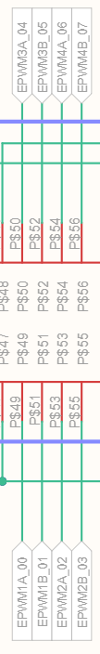

### Figure 9. Schematic to locate the PWM modules used for testing

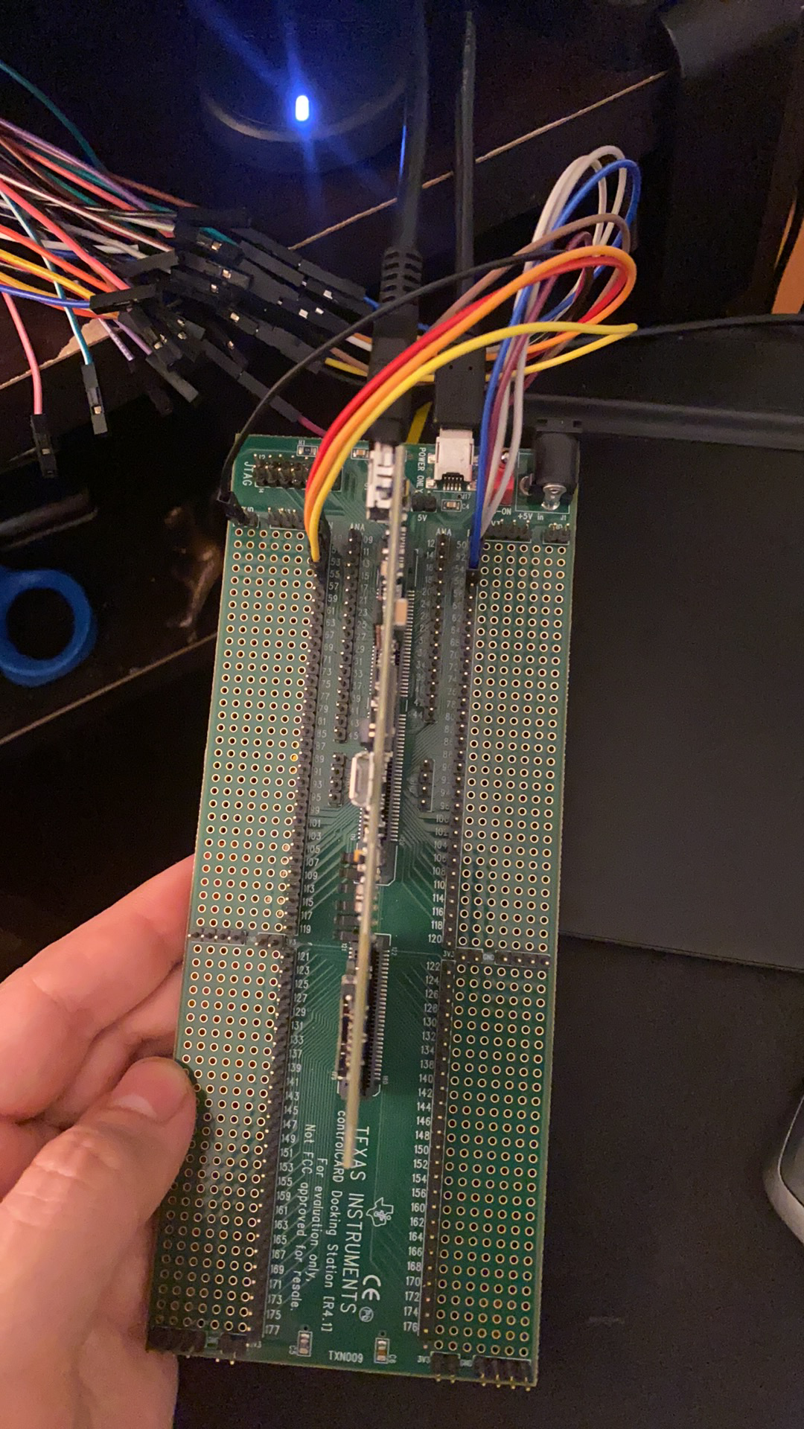

### Figure 10. DSP board with test board, probed by the ADALM2000’s Logic Analyzer

## B. Adapted Sorting Algorithm

In order to test the current hardware system, the algorithm from Professor Badawy’s paper [1] needed to be simplified, in order to accommodate the lack of UCs. Anything in the algorithm that included any purpose behind additional modes of operations regarding the UCs was removed while the test code was written. In order to update the PWM modules in an organized fashion, a PWM module matrix is made which includes the status of each of the four switches for each H bridge. The printed matrix manipulations of the test code can be seen in Figures 10 - 11.

### 

### Figure 11. Creating and sorting the main matrix based on SOC

### 

### Figure 12. Evaluating the PWM modules with highest SOC and updating main matrix

## C. PWM Output Results

After the test code was written to verify the logic of the algorithm, it was then implemented into the main code and tested on the DSP to get the result in Figure 12. Once it was successfully tested on the DSP, it was then tested on the hardware setup in the lab to generate the outputs shown in the remaining figures, the code was adjusted over the course of both semesters in order to get desirable results.

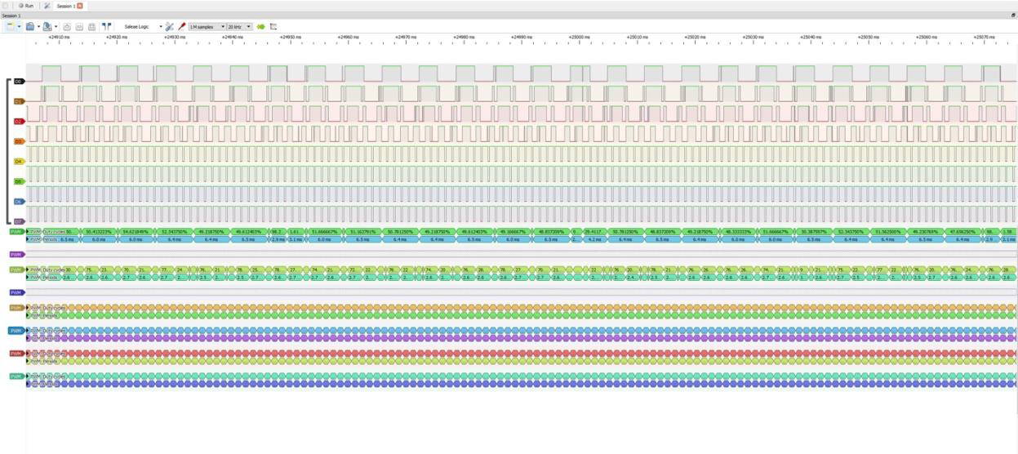

### Figure 13. PWM waveforms with level 4 on DSP

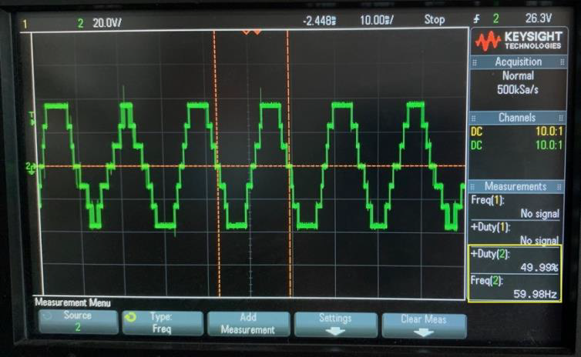

### Figure 14. Waveforms before SOC Algorithm

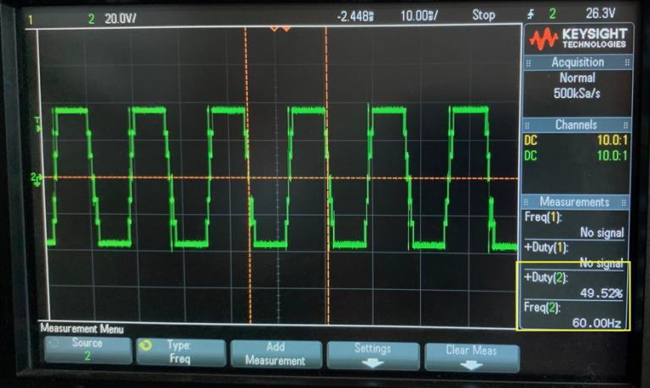

### Figure 15. Waveforms after SOC Algorithm

### 

### Figure 16. Waveforms before SOC Algorithm (zoomed in)

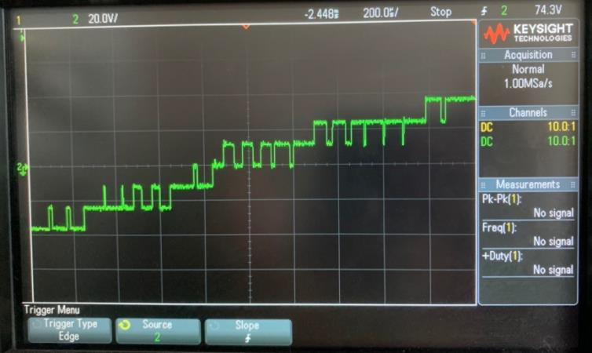

### Figure 17. Waveforms after SOC Algorithm (zoomed in)

## D. Kalman Filter Research

In order to continue to make progress on implementing more features into the main code, a majority of the time was needed to understand the overall system better of how the Model Predictive Control fit in (Figure 17). The previous work that had been done with regards to the Model Predictive Control included one main simulation done in MATLAB called “Simple_Model” shown in Figure 18. This simulation includes a majority of the functions shown in the block diagram in Figure 17 but mostly focused on the Model Predictive Control.

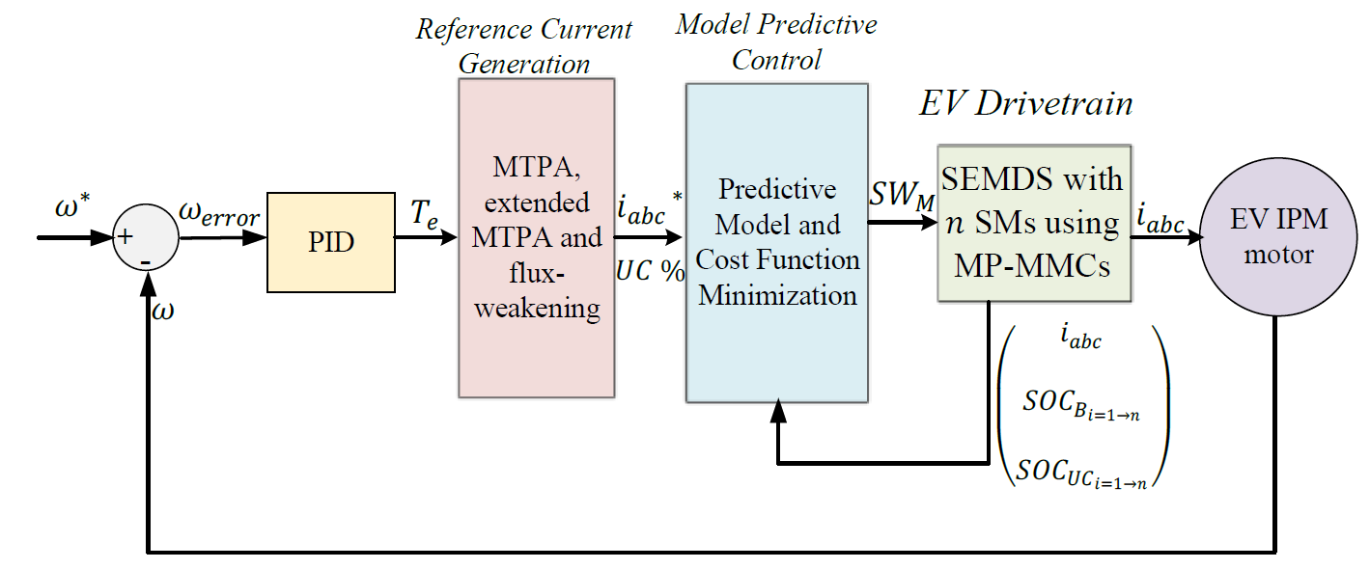

### Figure 18. MPC structure applied to MP-MMCs for an EV drivetrain

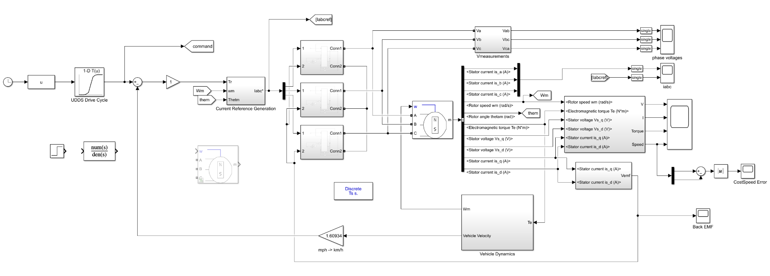

### Figure 19. MPC structure simulation in MATLAB

Given the dense amount of functionality in the overall system, what was focused on for a new implementation was State of Charge (SOC) Estimation. The current status of SOC Estimation is shown below in Figure 19 where dummy data is generated in order for the sorting algorithm discussed previously to have something to use when flashed onto the hardware. Ultimately, the goal would be to replace this code with an adaptation of the MATLAB simulation work done by a previous project member on the Kalman Filter shown (Figure 22). The voltage and current input data for this simulation was generated by a simple LTspice model shown in Figure 20. This LTspice model and MATLAB simulation work was based on the theory (Figure 21) highlighted in the IEEE paper that Dr. Badawy published [1].

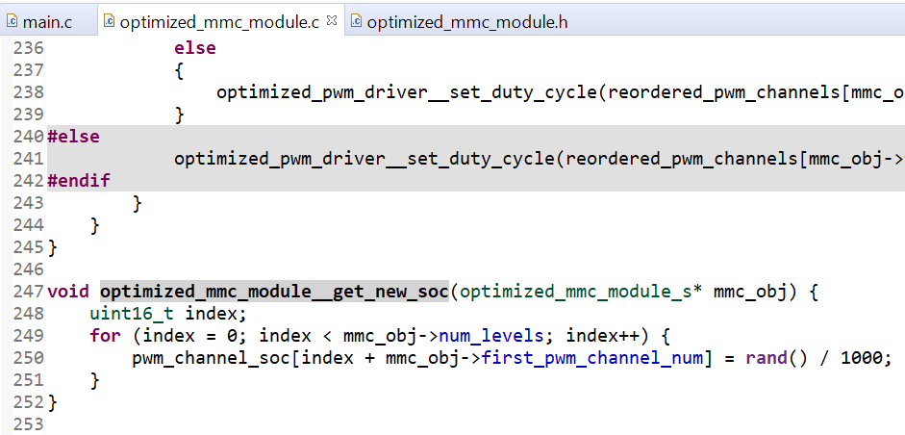

Figure 20. Current SOC implementation in main code

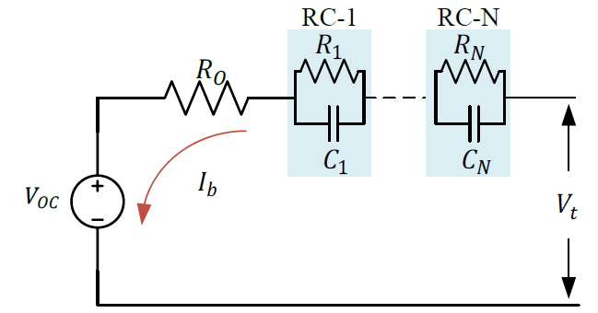

### Figure 21. Equivalent circuit model used for the Li-ion battery cells

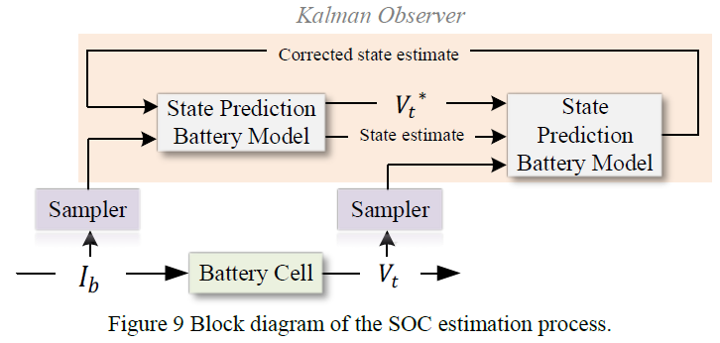

### Figure 22. Block diagram of the SOC estimation process

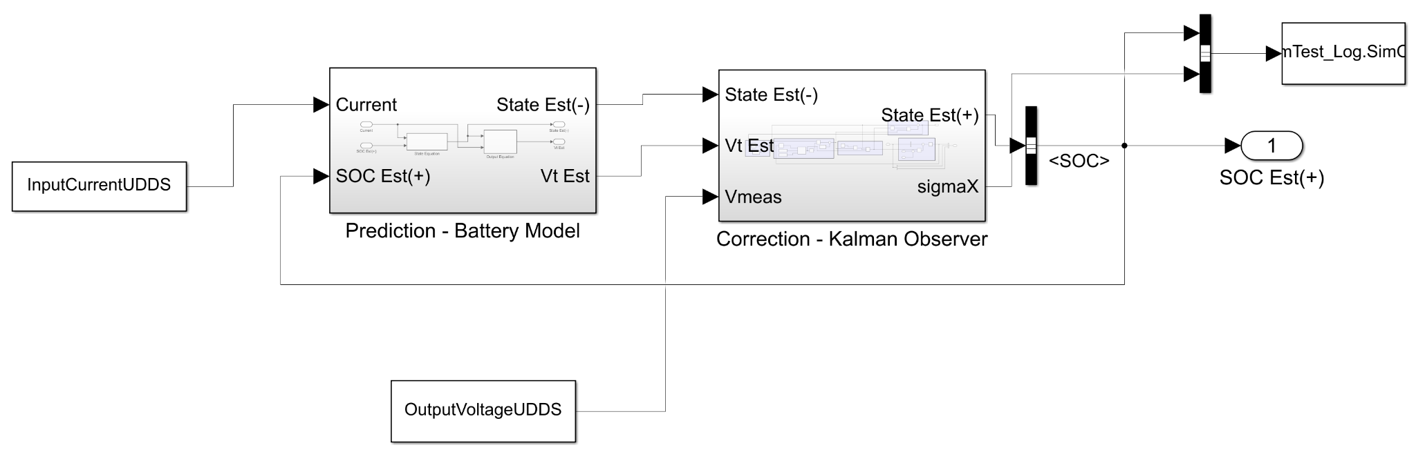

### Figure 23. Kalman Filter simulation in MATLAB

With an understanding of the overall system and how the Kalman Filter fits in, the next steps were to start looking for how this functionality could be observed together and implemented into the main code. One potential avenue would be combining the Kalman Filter simulation with the Simple Model simulation to see how it affects the behavior. However, a more impactful route would be adapting the work done on the Kalman Filter and converting it into C code to push to the main code. Given the dense amount of understanding and research that had to be done, the code was not able to be written but what we did find were several resources on Kalman Filter C implementation as well as Kalman Filter-specific, C code generation from MATLAB. These resources can be found here <https://github.com/sunsided/kalman-clib>, <https://www.mathworks.com/help/coder/ug/c-code-generation-for-a-kalman-filtering-algorithm.html>

# V. Future Work and Considerations

One consideration for the future of the current sense module is to change out the optocoupler and replace it with a QAM (Quadrate am circuit. Because we have an analog signal that is carrying information, we cannot use a transformer to isolate both sides of the circuit. The isolation from a transformer will transfer the voltage levels, but not the information that is held in the signal. We considered a QAM circuit because the analog signal we have is similar to a telecommunication signal. The QAM circuit can eliminate the optocoupler, the buffer stage, and the Zener diode.

For future work in the Embedded Systems sub team, there are two main avenues for learning and work that has been outlined with the Kalman Filter research. At a simulation level, to be able to see how the Kalman Filter changes the system performance, it would be recommended to take the existing Kalman Filter and Simple Model Simulink Models and combine them. At a code level, the SOC estimation in the main code is currently just a random set of values so this is where a code version of Kalman Filter would have to be written and implemented. Currently, the data used as input to the Kalman Filter Simulink model is generated from an LTspice Model, but sensors would have to be utilized in the hardware system to fully utilize its effectiveness for the main code.

# VI. Conclusion

As mentioned previously, the sales of EVs are projected to increase as time goes on, but the cost of purchasing an electric vehicle does not seem to be reducing anytime soon. In order to solve this issue, our team is dedicated to designing and developing the Multilevel Modular Converter for Energy Management Systems in electric vehicles.

For the PMD team, we redesigned and resimulated the current sense module with new components and component values to accommodate the changes that were done for the ICs that went out of stock. Furthermore, we edited the board layout for the PCB to fit into the standard capabilities that was laid out by Bay Area circuits, effectively reducing the cost of the board.

For the Embedded Systems team, we have designed, implemented, and tested a more efficient sorting algorithm into the main code. Along with this, we have also laid the ground for the next step of improvement and implementation for the Kalman Filter.

# 

# References

[1] M. Badawy, M. Sharma, C. Hernandez, A. Elrayyah and J. Coe, "Model Predictive Control for Multi-Port Modular Multilevel Converters in Electric Vehicles Enabling HESDs", IEEE Transactions on Energy Conversion, pp. 1-1, 2021. Available: <<https://ieeexplore-ieee-org.libaccess.sjlibrary.org/document/9457037>> [Accessed 29 November 2021].

[2] S. S. George and M. O. Badawy, A Modular Multi-Level Converter for Energy Management of Hybrid Storage System in Electric Vehicles, 2018 IEEE Transportation Electrification Conference and Expo (ITEC), Long Beach, CA, USA, 2018, pp. 336-341, doi: 10.1109/ITEC.2018.8450237. Available at: <<https://ieeexplore-ieee-org.libaccess.sjlibrary.org/document/8450237>> [Accessed 29 November 2021].

[3] T. Randall, "Here’s How Electric Cars Will Cause the Next Oil Crisis", Bloomberg.com, 2016. [Online]. Available: <<https://www.bloomberg.com/features/2016-ev-oil-crisis/>> [Accessed: 08 May 2021].

[4] Texas Instruments, “TMCS1100 1% High-Precision, Basic Isolation Hall-Effect Current Sensor With ±600-V Working Voltage,” SBOS820A datasheet, Sept. 2019

[Revised Jun 2020].

[5] Texas Instruments, “LM4030 SOT-23 Ultra-High Precision Shunt Voltage Reference,”

SNVS552B datasheet, March. 2008 [Revised 2013].